**CSC 417 Unit 1 Day 1 Outline**

1. Advanced Computer Games
   1. Game playing is a (uniquely) activity
      1. Competition/measuring our progress against others
      2. Challenging ourselves to improve
      3. Useful for investigating the nature of human intelligence
   2. Checkers (Arthur Samuel)
      1. Why checkers?
         1. Non-deterministic (different outputs possible for identical inputs)
         2. Clear goal (remove opponent’s pieces)
         3. Clear rules (easily described)
         4. Established knowledge (many human experts)
         5. Understandable to even “casual” observers
      2. Minimax
         1. System defaulted to looking 3 moves ahead
         2. Exceptions that increased search depth:
            1. Considering a jump
            2. Last move was a jump
            3. Piece exchange possible
      3. Notation
         1. 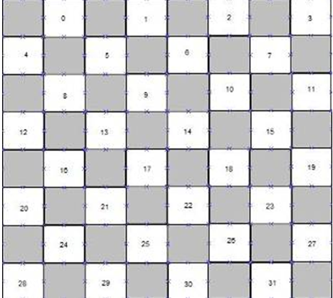Light colored squares are numbered
      4. Heuristics
         1. Piece advantage
         2. Denial of occupancy (board control)
         3. Mobility
         4. Hybrid measure of control of board center plus piece advancement

Moves that were not referenced for a long period were “forgotten” – storage space was expensive

* + 1. Rote Learning (repetition/memorization)
       1. Lacked sense of direction (*how* do we achieve the goal)
       2. Program could memorize a good sequence of moves but did not “understand” how to win
    2. Generalized Learning
       1. Alpha program
          1. Updated evaluation of moves during a game
       2. Beta program
          1. Updated evaluation of moves after a game
       3. Programs played each other repeatedly to develop a collection of good moves
       4. Resulting program was above average, but had limitations:
          1. Easily fooled by deliberate bad play (opponent could make a non-optimal move to “throw off” the system)
          2. Evaluation function changed too quickly
          3. Overvalued “flashy plays” (favored large score swings over basic moves that set up later wins)

Search algorithms such as Minimax are good at games like checkers, but what about replicating human AI for a game such as Skyrim?